Class Work – Comp392-001- Feb.14th

Fabio Alexandre Ciconi – 300930989

# Setup Environment:

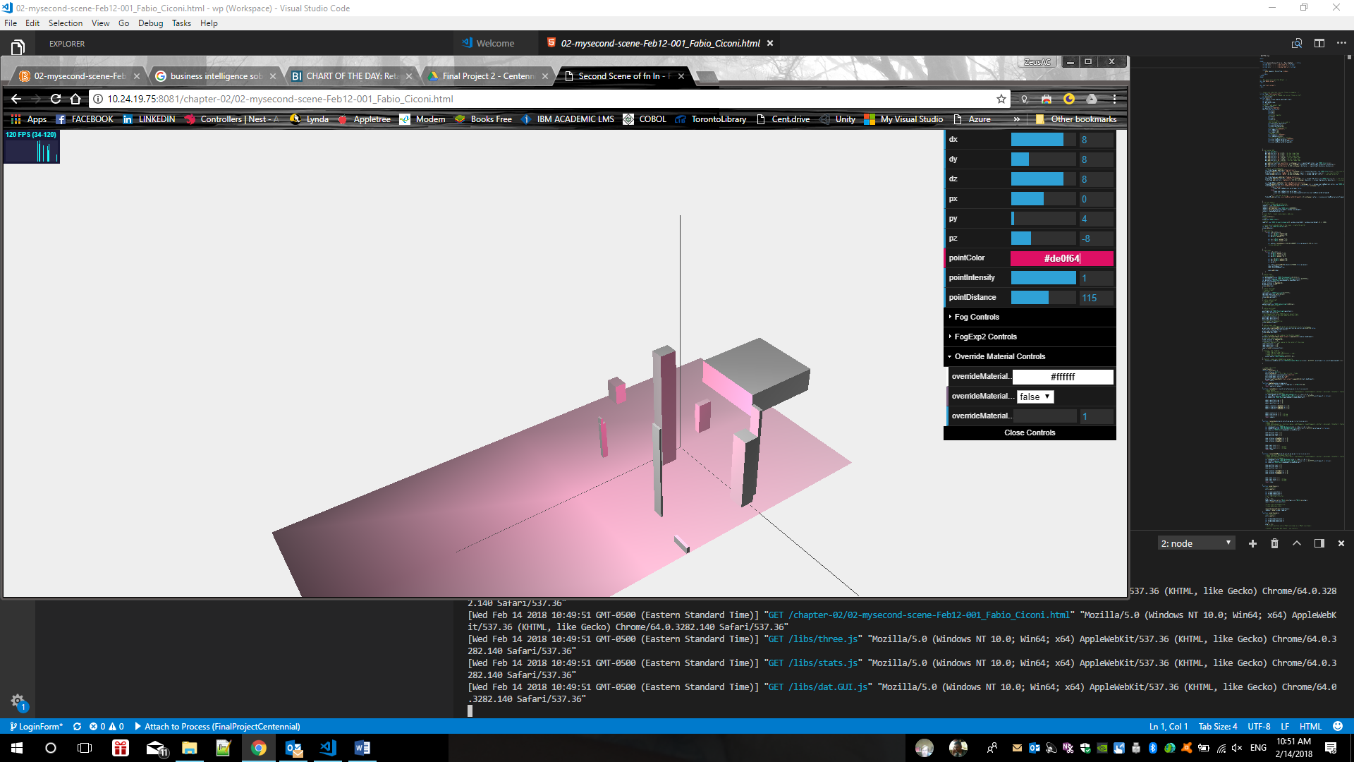

# tetrahedron

